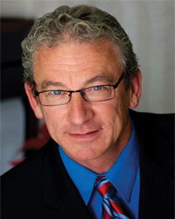
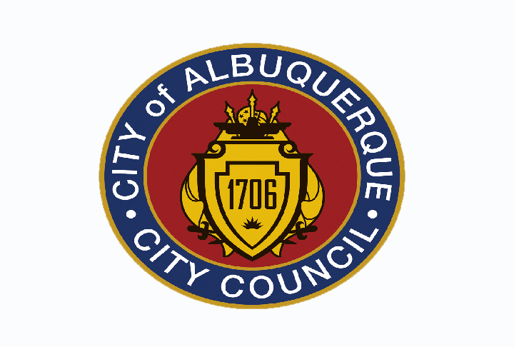
Albuquerque City Councilor

Michael D. Cook

cordially invites you to a town hall meeting on
District Seven issues

Wednesday, June 22, 2011, 6pm – 7:30pm.

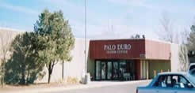
Palo Duro Senior Center
5221 Palo Duro NE – Albuquerque, NM
Off San Mateo Blvd, one block north of Comanche,
Next to Erna Ferguson Library

REFRESHMENTS PROVIDED

For more information, please contact: Tony Duran (505) 768-3136, tduran@cabq.gov

